## Abrahamic Covenant

The Abrahamic Covenant is God's promise to Abraham and his descendants. Abraham was promised land (the land of Canaan), seed (descendants), and blessing (through faith) forever if they utilize God’s grace provision. This is the basic covenant. The Abrahamic Covenant is found in the conversation between God and Abraham in Genesis 12, 13, 15, 17, and 22.

The Abrahamic Covenant defines the new race of Jews for the nation of Israel. Abraham became the first of a race of Jews and the first Jewish believer at age 99. His circumcision was the outward sign of his belief in the future Messiah for salvation.

The Abrahamic Covenant says that the seed of the woman, the humanity of Christ, will descend from Abraham, Isaac, and Jacob. Gen. 12:1-3; Gen. 13:15-16; Gen. 15:18; Gen. 22:15-18; Gen. 26:3-4; Exodus 6:2-8.

"Now the LORD said to Abram, "Go forth from your country, And from your relatives And from your father's house, To the land which I will show you; And I will make you a great nation, And I will bless you, And make your name great; And so you shall be a blessing; And I will bless those who bless you, And the one who curses you I will curse. And in you all the families of the earth will be blessed."" (Genesis 12:1-3, NASB)

"for all the land which you see, I will give it to you and to your descendants forever. "I will make your descendants as the dust of the earth, so that if anyone can number the dust of the earth, then your descendants can also be numbered." (Genesis 13:15-16, NASB)

"On that day the LORD made a covenant with Abram, saying, "To your descendants I have given this land, From the river of Egypt as far as the great river, the river Euphrates:" (Genesis 15:18, NASB)

“"Sojourn in this land and I will be with you and bless you, for to you and to your descendants I will give all these lands, and I will establish the oath which I swore to your father Abraham. "I will multiply your descendants as the stars of heaven, and will give your descendants all these lands; and by your descendants all the nations of the earth shall be blessed;” (Genesis 26:3-4, NASB)

The first eleven chapters of the Bible cover many, many years. Actually these chapters are the introduction to the Old Testament. Suddenly in Genesis 12, rapid chronology comes to a stop. One human family is selected and described in great detail.

The three most important verses in all of the Word of God are found in Genesis 12:1-3. Abraham is promised three things by God: land, seed, and blessing. This foundational promise gives us the theme of the entire Bible and everything is related to it.

The diagram below pictures the foundational Abrahamic Covenant and shows the relationship of the three other unconditional covenants to Israel. The basic Abrahamic Covenant is constantly repeated and explained in the Bible. The land promises are amplified in the Palestinian Covenant. The seed promises are amplified in the Davidic Covenant. The blessing promises are amplified in the New Covenant.

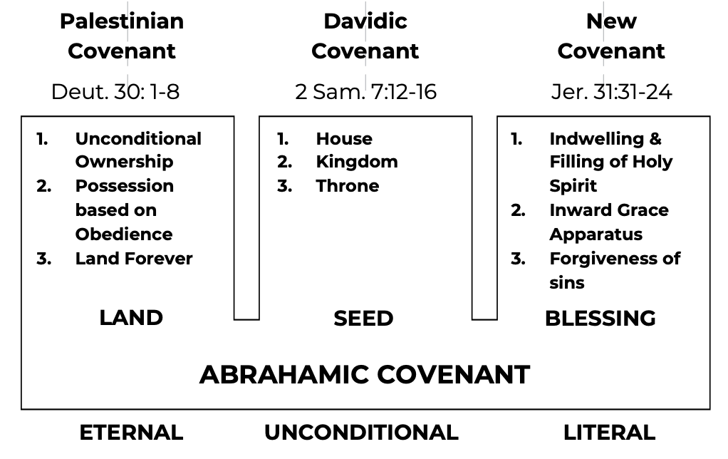

The Abrahamic Covenant is found in Genesis 12, 13, 15, 17 and 22. It is a clear text. Interpretation of this covenant affects related theology, especially in the areas of Eschatology and Soteriology. Consequently, there are four major points to stress regarding this covenant.

This covenant is to be interpreted literally. This covenant is eternal in its expanse. This covenant is unconditional on Abraham’s part. This covenant was made with the nation Israel, that is with Abraham and his descendants, not Gentiles. Note that the blessing of Abraham is to come upon the Gentiles also. Heb. 6:13-20; Gal. 3:13-18; Rom. 4:1-5.

“For when God made the promise to Abraham, since He could swear by no one greater, He swore by Himself, saying, "I WILL SURELY BLESS YOU AND I WILL SURELY MULTIPLY YOU."” (Hebrews 6:13-14, NASB)

“Christ redeemed us from the curse of the Law, having become a curse for us—for it is written, "CURSED IS EVERYONE WHO HANGS ON A TREE"— in order that in Christ Jesus the blessing of Abraham might come to the Gentiles, so that we would receive the promise of the Spirit through faith.” (Galatians 3:13-14, NASB)

“What then shall we say that Abraham, our forefather according to the flesh, has found? For if Abraham was justified by works, he has something to boast about, but not before God. For what does the Scripture say? "ABRAHAM BELIEVED GOD, AND IT WAS CREDITED TO HIM AS RIGHTEOUSNESS."” (Romans 4:1-3, NASB)

**Exposition of the Abrahamic Covenant**

Genesis 12:2-3 forms the seed-plot for the entire Word of God and for the nation of Israel regarding God’s dealing with the covenant people. Israel begins here. Therefore, these verses are introductory and are very important.

"And I will make you a great nation, And I will bless you, And make your name great; And so you shall be a blessing; And I will bless those who bless you, And the one who curses you I will curse. And in you all the families of the earth will be blessed."" (Genesis 12:2-3, NASB)

We are dealing with foundations here. An illustration of this is found in the builder’s trade. Sometimes it takes as long to drive the piles and prepare the foundation for a 50-story skyscraper as it does to construct the tower superstructure. It is important that the right foundation is laid in the Bible so that the superstructure (the other 65 books) does not lean and topple. The Bible can be likened to a 66 story building with Genesis as the foundation and Revelation as the penthouse. There are at least four things promised in Genesis 12:2-3.

“A great nation.” What does a nation need? People and land. God promised Israel land and a great number of people.

“I will bless you.” Abraham will be blessed materially and spiritually. He will be a channel of blessing for untold millions.

“And make your name great.” What made a name great in those days? Progeny! This indicates that Abraham will have children that will populate the land. The Old Testament uses the term “seed” to indicate children.

“And in you all the families of the earth will be blessed.” His appointment includes being the possessor and dispenser of the blessing. Blessing and cursing of men to be dependent entirely upon their attitude toward Abraham and to his descendants. A curse means to not prosper in contrast to blessing which means to prosper. The blessing promised to Abraham was to unite the divided families of the world.

There is great emphasis here on land, seed, and blessing. Was this real land? Real estate? Really? Remember that it was real land promised here on earth, not in heaven. Every time the word “land” appears in the Bible, it means just that, land. The literal interpretation of the Bible is very important. Gen. 12:5.

"Abram took Sarai his wife and Lot his nephew, and all their possessions which they had accumulated, and the persons which they had acquired in Haran, and they set out for the land of Canaan; thus they came to the land of Canaan." (Genesis 12:5, NASB)

Land is needed for a nation. A nation cannot exist without land and the seed promise provides for the people to dwell in that land. Blessing will come as a result. Gen. 13:14-17.

"The LORD said to Abram, after Lot had separated from him, "Now lift up your eyes and look from the place where you are, northward and southward and eastward and westward; for all the land which you see, I will give it to you and to your descendants forever. "I will make your descendants as the dust of the earth, so that if anyone can number the dust of the earth, then your descendants can also be numbered. "Arise, walk about the land through its length and breadth; for I will give it to you."" (Genesis 13:14-17, NASB)

By the way, how long was this land given to Abraham and his seed? Look at Genesis 13:15. Forever. Abraham and his descendants were promised real land forever. Will there be real land in eternity then? Is there anything that talks about an eternal earth in the Bible? Yes, it does in Revelation 21 – the New Heavens and the New Earth including the New Jerusalem. Read it.

"for all the land which you see, I will give it to you and to your descendants forever." (Genesis 13:15, NASB)

Up to this point, Abraham has been promised seed, but not too specifically. In Genesis 13, however, he is directly told that he is going to have a group of descendants too large to count. Abraham is also told to walk throughout the whole land. This was the land of Canaan. It was given to him as a grace gift from God. Did Abraham deserve this gift? No. Abraham didn’t deserve anything. It was unconditionally given to him and his seed on the basis of grace. Gen. 13:16.

“"I will make your descendants as the dust of the earth, so that if anyone can number the dust of the earth, then your descendants can also be numbered.” (Genesis 13:16, NASB)

**The Names of Abraham and Sarah**

Abram means “father of high and lofty places” or “father of the winds.” When his name was lengthened to Abraham, it meant “father of many nations.” Sarai meant “contentious or nagger.” But later it was changed to Sarah which meant “princess.” The meaning of names was much more important in the Old Testament than today. Again, the grace of God was extended to Abraham and his wife. A close study of this family will convince the Bible student that they were very human and had their failures. The Bible always gives an honest account. Gen. 15:1-3.

"After these things the word of the LORD came to Abram in a vision, saying, "Do not fear, Abram, I am a shield to you; Your reward shall be very great." Abram said, "O Lord GOD, what will You give me, since I am childless, and the heir of my house is Eliezer of Damascus?" And Abram said, "Since You have given no offspring to me, one born in my house is my heir."" (Genesis 15:1-3, NASB)

In Genesis 15:1, “I am a shield to you” uses the word “shield” and is מְגִנָּה (meginnah) and means protector. In “Your reward shall be very great,” the word “reward” is used and is שׂכר (śâkâry) and means compensation for work done, wages, salary. Abraham was living in wild, open, rough and barren country.

What was Abraham’s problem? God had promised him land, seed, and blessing. It looked like he’d been given everything. Abraham’s problem was in his human viewpoint because he had no children at that time and was far too old to produce any. Abraham was 75 and Sarah was 65 when they left Haran. They were “over the hill” as far as having children was concerned.

Abraham almost seemed to think that God didn’t know the facts of life. Abraham was smart enough to know that he could not farm a ranch the size of Canaan without help. Actually, the land and blessing promises meant little or nothing without children. So he was concerned because he was thinking human viewpoint instead of divine viewpoint. What would you be thinking under these circumstances?

Eliezer, according to custom, would inherit Abraham’s goods since there was no child, so Abraham suggested this to God. God said “no” in Genesis 15:4-5.

"Then behold, the word of the LORD came to him, saying, "This man will not be your heir; but one who will come forth from your own body, he shall be your heir." And He took him outside and said, "Now look toward the heavens, and count the stars, if you are able to count them." And He said to him, "So shall your descendants be."" (Genesis 15:4-5, NASB)

This was rather frank, wasn’t it? God told Abraham that he didn’t have to worry. God always carries out what He promises. “You are going to have children.” God reassures him that Eliezer will not be his heir. Then, he is challenged to count the stars. This illustrates innumerable seed.

Do you get the picture here? Abraham was told he will have children, but he doesn’t have any. He was too old. Absolutely impossible! What was Abraham to believe? The clear promise of God! Will he believe it or won’t he?

Abraham believed in the Lord as his Messiah to come and in response to that positive volition, God counted it to him for righteousness. God imputed His very own perfect righteousness to Abraham. Abraham was now a believer. Gen. 15:6.

"Then he believed in the LORD; and He reckoned it to him as righteousness." (Genesis 15:6, NASB)

Believing must be in the Lord and must be personal. Abraham had believed in the future work of the Messiah – the Lord Jesus Christ while he lived in Ur of the Chaldees. We see this from the perfect tense of the Hebrew verb אמן ('âman) which indicates an action that had already been completed in the past with continuing results.

When Abraham had believed in Ur of the Chaldees, it had been credited to him as absolute righteousness. The term “reckoned” is חשׁב (châshaba) and is a bookkeeping term. Abraham, because of sin and human good was completely in debt to God with no ability to ever pay the debt. He was on the minus side of the ledger. Rom. 3:23; Isaiah 64:6.

"for all have sinned and fall short of the glory of God," (Romans 3:23, NASB)

"For all of us have become like one who is unclean, And all our righteous deeds are like a filthy garment; And all of us wither like a leaf, And our iniquities, like the wind, take us away." (Isaiah 64:6, NASB)

Although Jesus Christ had not yet died on the cross, God knew with absolute certainty in eternity past that Jesus Christ would go to the Cross and die spiritually for the sins of mankind. God is omniscient, so He knew exactly how the future would unfold. 1 Peter 1:19-20.

"but with precious blood, as of a lamb unblemished and spotless, the blood of Christ. For He was foreknown before the foundation of the world, but has appeared in these last times for the sake of you" (1 Peter 1:19-20, NASB)

Abraham was in debt so far he could never work it off. So Christ paid the debt through the Cross thus erasing the debt. Then, God goes a step further and gives him His very own perfect absolute righteousness. Just as Abraham had believed for salvation so he is to believe that God will keep His promises to him. Rom. 8:32.

"He who did not spare His own Son, but delivered Him over for us all, how will He not also with Him freely give us all things?" (Romans 8:32, NASB)

But Abraham continues to worry by asking God in Genesis 15:8 how he will know that God's promise has been fulfilled. So he was told to take some animals and lay them out thus and so. Later on he goes into a deep sleep. God then by grace, enacts the Abrahamic Covenant.

"He said, "O Lord GOD, how may I know that I will possess it?"" (Genesis 15:8, NASB)

Worry had gotten Abraham out of fellowship and he needed to confess sin biblically. From Genesis 15:12 on, a knowledge of prophecy is offered. If you are not afraid of death and life after death, it will cut down on the nightmares of life.

"Now when the sun was going down, a deep sleep fell upon Abram; and behold, terror and great darkness fell upon him." (Genesis 15:12, NASB)

Romans 4 also follows this pattern. First, it stresses salvation by grace not works in Romans 1-11. Then, on the basis of having believed in the Lord for salvation, Abraham kept on believing that God could fulfill His promises in Genesis 15:13-25.

**Confirmation of the Covenant**

Abraham wanted a confirmation of this promise as it transcended all human thinking. There were several ways to confirm a covenant in those days. By exchanging a bag of salt between the two parties or exchanging sandals before witnesses, were two ways.

By the blood covenant. This blood covenant involved killing animals, splitting them, forming a corridor between the haves and then the two parties would walk through the corridor together. Should one party fail in his obligation he must be killed even as the animals were killed. The more animals the richer the parties involved and the more serious the contract - a heifer as a sin offering, a she goat as a reconciliation offering, a ram as a propitiation offering, a turtle dove representing the deity of Christ, and a young pigeon representing the resurrected humanity of Christ.

What happened when Abraham fell into a deep sleep in Genesis 15:12? He dreamed that there would be a 400-year period in which Israel would not dwell in the promised land. They were to be afflicted by a foreign power (Egypt) but were promised one day to be in the land. Then, symbolized by a flaming torch (God) identified with a smoking stove (Abraham and his seed--Abraham asleep) God moved alone between the slain animals. This signified that he assumed all responsibility and Abraham and his seed were the receivers. God thus assumed the responsibility for keeping the eternal covenant in effect. Gen. 15:17-18.

“Now when the sun was going down, a deep sleep fell upon Abram; and behold, terror and great darkness fell upon him.” (Genesis 15:12, NASB)

“It came about when the sun had set, that it was very dark, and behold, there appeared a smoking oven and a flaming torch which passed between these pieces. On that day the LORD made a covenant with Abram, saying, "To your descendants I have given this land, From the river of Egypt as far as the great river, the river Euphrates:” (Genesis 15:17-18, NASB)

God then extended the boundary line of the land involved. It projects from the Nile River to the Euphrates River. Even various tribes living in these geographical boundaries are mentioned.

Sarah had fallen for the old cliché, “God helps those who help themselves.” It brought her nothing but heartache. The whole Arab-Israel conflict begins right here in Genesis 16. Genesis 16:12 shows the general behavior of the Arab.

""He will be a wild donkey of a man, His hand will be against everyone, And everyone's hand will be against him; And he will live to the east of all his brothers."" (Genesis 16:12, NASB)

Abraham loses his old name of Abram in Genesis 17. Father of the winds is changed to father of many nations. And this was changed before Isaac was born. Can you visualize Abraham going to town after his name was changed and having people say, “Hi, Abram” and Abraham would say, “My name is not Abram, it’s Abraham.” And they would look around and say, “Well, where are the kids?” For Abraham meant father of many children. Gen. 17:5.

“"No longer shall your name be called Abram, But your name shall be Abraham; For I have made you the father of a multitude of nations.” (Genesis 17:5, NASB)

His name must have been a real crowd-stopper. Imagine. Abraham had to answer by faith. Ishmael was the only one and he was of the flesh. So God confirms again the Abrahamic Covenant in Genesis 17:6-8, and the outward sign of the covenant was levied as circumcision. Circumcision is the ritual of confirmation and acknowledgment of God’s grace. Sarai’s name (contentious) was changed to Sarah (princess). From a nagger, she became a princess in disposition by the grace of God.

""I will make you exceedingly fruitful, and I will make nations of you, and kings will come forth from you. "I will establish My covenant between Me and you and your descendants after you throughout their generations for an everlasting covenant, to be God to you and to your descendants after you. "I will give to you and to your descendants after you, the land of your sojournings, all the land of Canaan, for an everlasting possession; and I will be their God."" (Genesis 17:6-8, NASB)

In Genesis 21, the child Isaac (laughter) was born as promised. And it was a miracle because their combined ages total 190. Friction again was seen in this chapter between Ishmael and Isaac. And this friction will not stop until the Second Advent.

“Now Abraham was one hundred years old when his son Isaac was born to him. Sarah said, "God has made laughter for me; everyone who hears will laugh with me."” (Genesis 21:5-6, NASB)

Then finally in Genesis 22, Isaac is offered as a sacrifice on the mountain that one day Christ would die upon and the covenant was confirmed to Abraham in Genesis 22:17-18. Abraham offered his son Isaac, only to receive him back. This taught both individual blessing imputed to the mature believer and blessing by association to the nation and even to other nations.

"indeed I will greatly bless you, and I will greatly multiply your seed as the stars of the heavens and as the sand which is on the seashore; and your seed shall possess the gate of their enemies. "In your seed all the nations of the earth shall be blessed, because you have obeyed My voice."" (Genesis 22:17-18, NASB)

Abraham had grown in the Lord, and was blessed exceedingly. Abraham again quoted the promises in Genesis 24:7 and in Genesis 26 the covenant was confirmed to Isaac, and then to Jacob in Genesis 28. Further references through the Old Testament prove that their prosperity or disgrace revolved around the promises made to Abraham.

""The LORD, the God of heaven, who took me from my father's house and from the land of my birth, and who spoke to me and who swore to me, saying, 'To your descendants I will give this land,' He will send His angel before you, and you will take a wife for my son from there." (Genesis 24:7, NASB)

The Abrahamic Covenant relates to the nation of Israel whereby Abraham and his spiritual seed are the beneficiaries of God's blessing and grace provision. Abraham believed in God’s promise that he and Sarah would have a son and that God was also able to fulfill His promise.